FAST
Food and
Sustainability Thrive

Erasmus+ meeting in Poland, 5th- 9th March, 2017
Warm – up
1.“Food and sustainability Thrive”- FAST for short. Take a piece of paper and in mixed Dutch-Polish groups of 6-7 people write down as many words related to our project as you can.
What is sustainability?
Overview
The word, “sustainability,” has many definitions. In fact, definitions of sustainability can shift when this word is used in local, regional, and global contexts. This activity introduces students (and teachers) to the concept of sustainability so that they may better understand its many meanings, including what this big word means to them personally. Sustainable development is development that meets the needs of the present without compromising the needs of future generations to meet their own needs.

ACTIVITIES
1. Divide students into teams. Students can work individually, in partners, or in small groups, depending on your learning context.
2. In a short brainstorming session, ask teams to think about and discuss the word, “sustainability.” What does this word mean?
3. Next, each team will compose a sustainability vocabulary illustration.
***4. After illustrations are complete, teams should share their illustrations with other teams. Discuss similarities and differences between illustrations. Can the class compose a common definition for sustainability for their community?

Hints
- Vocabulary illustrations can be composed with paper and pencils, magazine clippings, or digital tools in order to include images, sounds, and hyperlinks to websites.
- Teams should use Earthducation resources to help identify an example of sustainability
- .Access free images of sustainability using Creative Commons (http://www.creativecommons.org)
Extensions
- Watch the Eartheducation video and use the material and ideas provided.
- Use interactive whiteboards to create a class vocabulary illustration.
- Create electronic vocabulary posters that incorporate images, text, music, and video
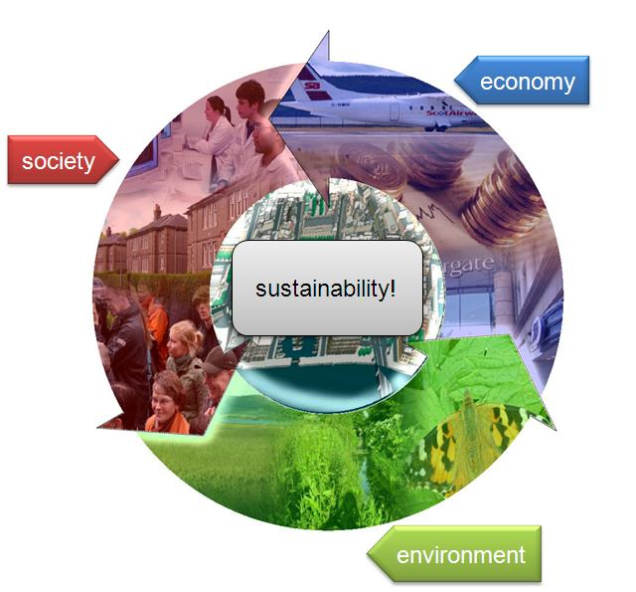
TASKS
1.What is sustainability ? Try to work out the definition and illustrate it with photos/pictures/ect. Search the Internet and find necessary materials. Make a poster illustrating the word. Here are some useful LINKS:
http://www.environmentalscience.org/sustainability
https://sustainability.ncsu.edu/about/what-is-sustainability/
https://www.mcgill.ca/sustainability/files/sustainability/what-is-sustainability.pdf
https://en.wikipedia.org/wiki/Sustainability\
http://www.simplebites.net/10-tips-for-sustainable-eating/

2. Watch a video on sustainability, start with No 1, if it is too difficult for you, please switch to No 2:
1. https://www.youtube.com/watch?v=rmQby7adocM
2. https://www.youtube.com/watch?v=gTamnlXbgqc

3. Search the website and answer the following questions:
What Is Sustainability and Why Is It Important?
……………………………………………………………………………………………………………………………………………………………………………………………………………………………………………………………………………………………………………………………………………………………………………………………………………………………………………………………………………………………………………………………………………………………...
Explain the Three Pillars of Sustainability. Try to find a diagram for it.
……………………………………………………………………………………………………………………………………………………………………………………………………………………………………………………………………………………………………………………………………………………………………………………………………………………………………………………………………………………………………………………………………………………………...……………………………………………………………………………………............
What are the Primary Goals of Sustainability?
……………………………………………………………………………………………………………………………………………………………………………………………………………………………………………………………………………………………………………………………………………………………………………………………………………………………………………………………………
………………………………………………………………………………………...……………………………………………………………….............................................

SUSTAINABILITY

Sustainability means ensuring that the planet Earth and all of its resources can continue to provide a home for humans, animals and plants forever.
Humans recognize that we have created some problems on Earth. These include loss of animal’s homes, air and water pollution, decreasing resources, climate changes and many other factors affecting our environment.
To protect our natural resources we must find sustainable solutions to problems that work we’ll now and in the future.
Why do you think it could be necessary to improve sustainability?
______________________________________________________________________________________________________________________________________________________________________________________________________________________________________________________________________________________________________________________________________________________________________________________________________________________________
What actions could be taken? at school/at home.
- ________________________________________________________________________________________________________________________________________________________________________________________________
_______________________________________________________________________________________________________________________________________________________________________________________________________________________________________________________________

- ________________________________________________________________________________________________________________________________________________________________________________________________
_______________________________________________________________________________________________________________________________________________________________________________________________________________________________________________________________
______________________________________________________________

The six Rs exercise.

Objective: to identify and explain what the 6rs of sustainability are.
Success Criteria: to design a poster based on one of these “R words”.

- _____________________________
- _____________________________
- _____________________________
- _____________________________
- _____________________________
- _____________________________
NOTES:
_______________________________________________________________________________________________________________________________________________________________________________________________________________________________________________________________________________________________________________________________________________________________________________________________________________________________________________________________________________________________________________________________________________________________________________________________________________________________________________________________________________________________________________________________________________________________________________________________________________________________________________________________________________________________________________________________

